“When sitting, a child with low tone may always sit on the floor in a position that resembles a W, bearing weight equally through his bottom, legs, knees, ankles, and feet. This widens his base of support and frees up his arms for play. In this position, the trunk is inactive and he often slumps. While this is a very stable, secure position, it does not encourage the development of postural control." (Lindsey Biel in Raising a Sensory Smart Child) 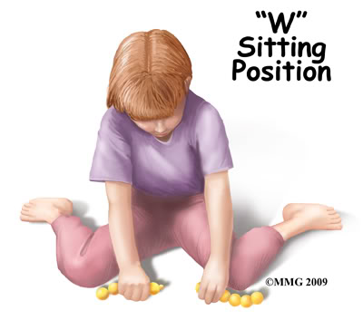
This position also takes the child away from sitting cross legged which encourages midline crossing thereby helping in bilateral coordination. Because there is low tone the child is unable to use efficient balance and coordination strategies. I have often found in my practice that such children demonstrate frequent falls, stumbling, seeking motion, jumping to name a few. Because proprioception forms a major component of Somato sensory processing, this child has difficulties, planning, organizing and coordinating his actions while at play or even simple to mimic someone who demonstrates the right position to sit.
The tonal problems are not only restricted to his arms and legs but manifest overall presence of low tone thereby affecting oro-motor skills like eating and speech. A speech delay or inefficient articulation is observed alongwith fast swallow or gulping of foods to avoid chewing, preference for particular foods. As regards the other oro-motor behaviours, these children also have difficulty forming O with lips, blowing bubbles, whistling.
A sensory rich program facilitating somato sensory processing, proprioceptive activities of body and oral area seem to immensely benefit these children.

